**Telecom Customer Churn Analysis Report**

**1. Introduction**

This report presents an in-depth analysis of telecom customer churn using the dataset WA_Fn-UseC_-Telco-Customer-Churn.csv. The goal is to explore key trends, identify factors affecting customer retention, and provide insights for reducing churn. Churn is a critical metric for telecom companies as it directly impacts revenue and growth.

**2. Data Overview**

The dataset includes customer demographics, service usage details, account tenure, and billing information. The key columns analyzed include:

* **CustomerID**: Unique identifier for each customer.
* **Churn**: Indicates whether a customer has left the service (Yes or No).
* **TotalCharges**: The total amount charged to the customer during their tenure.
* **MonthlyCharges**: The monthly billing amount for each customer.
* **Contract Type**: Customers can have Monthly, One-year, or Two-year contracts.
* **Payment Method**: Various payment modes like electronic checks, mailed checks, credit cards, and bank transfers.
* **Tenure**: The duration (in months) for which the customer has been using the service.

**3. Data Cleaning & Preprocessing**

* Checked for missing values and found that TotalCharges had some null values, which were handled appropriately.
* Converted TotalCharges to numeric format for accurate analysis.
* Categorical variables like Contract Type and Payment Method were encoded for visualization and model building.
* Outliers in MonthlyCharges and TotalCharges were analyzed to understand their impact on churn.

**4. Key Performance Indicators (KPIs)**

**4.1 Churn Rate**

* **Formula**: Churn Rate=(Churned Customers / Total Customers) × 100
* **Findings**: The churn rate is approximately **26.54%**, indicating the percentage of customers who discontinued service. A high churn rate suggests customer dissatisfaction or competitive market dynamics.

**4.2 Average Revenue per User (ARPU)**

* **Formula**: ARPU=∑TotalChargesTotal / Customers
* **Findings**: The ARPU was calculated as **$73.46** per customer, providing insight into the company’s revenue per subscriber.

**4.3 Customer Retention Rate**

* **Formula**: Retention Rate=100 − Churn Rate
* **Findings**: The retention rate was observed to be **73.46%**, indicating the percentage of customers retained.

**5. Exploratory Data Analysis (EDA)**

**5.1 Customer Segments with the Highest Churn**

* **Churn by Spend Category:** Customers with higher spend categories tend to churn more frequently, indicating potential pricing concerns.
* **Churn by Tenure Group**: Newer customers (lower tenure) show higher churn rates, suggesting onboarding challenges.
* **Churn by Contract Type:** Customers on monthly contracts churn at a significantly higher rate compared to those with one-year or two-year contracts.
* **Churn by Internet Service:** Churn rates vary based on the type of internet service customers subscribe to.

**5.2 Churn Trend Over Time**

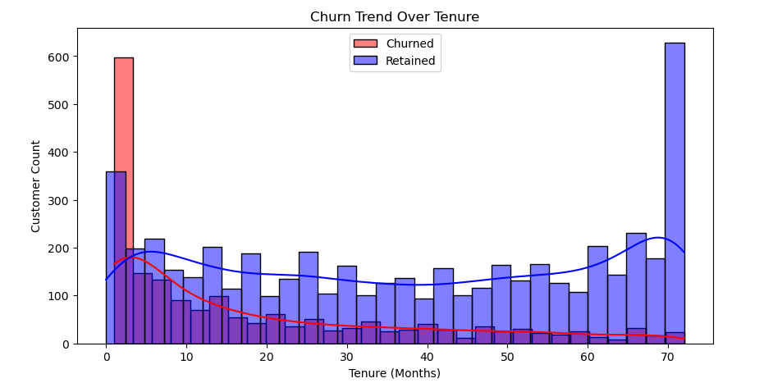

* Tenure is used as a proxy for time to analyze churn trends.
* Customers with lower tenure (less than six months) are more likely to leave, emphasizing the importance of early customer engagement.

**5.3 Support Interactions and Churn**

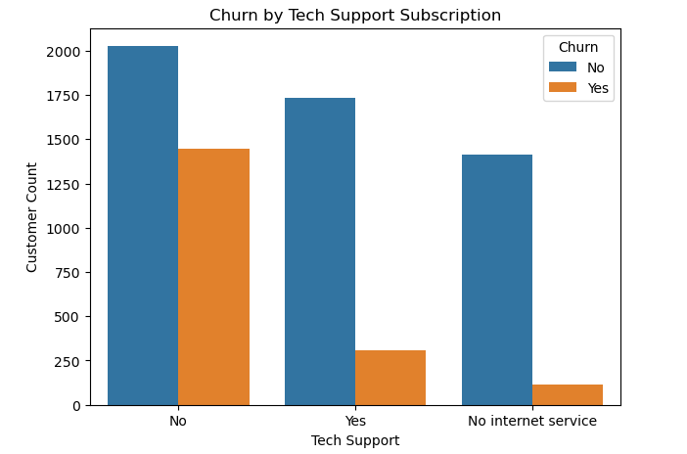

* Customers without Tech Support subscriptions churn at a significantly higher rate.
* Providing proactive customer support can improve retention.

**5.4 Usage Data and Churn**

* **Customers subscribed to multiple services tend to have lower churn rates.**
* **Services count is a critical factor in retention, as those using bundled services are less likely to leave.**

**6. Visualizations**

* **Churn Rate Distribution**: Bar charts and pie charts visualizing churn proportions.

* **Churn vs. Contract Type**: Box plots showing how contract length affects churn.

* **Churn by Payment Method**: Comparative analysis of churn rates based on different payment methods.

**7. Conclusion & Recommendations**

* **Encourage long-term contracts**: Customers with one- or two-year contracts have lower churn rates. Introducing discounts or benefits for long-term subscribers can reduce churn.
* **Offer flexible pricing models**: Reducing high monthly charges or providing loyalty discounts can improve retention.
* **Improve customer onboarding**: Addressing new customers' concerns early can lead to longer retention periods.
* **Enhance customer support**: Providing proactive customer support for high-risk customers can prevent churn.
* **Optimize payment methods**: Encouraging customers to use auto-pay methods can reduce involuntary churn.

This comprehensive analysis provides actionable insights for reducing customer churn, improving retention strategies, and optimizing telecom services.